Advanced Network Automation

Labs 4 & 5

Network Automation Framework (IaC) (Part 1 & 2)

University of Colorado Boulder

Department of Computer Science

Network Engineering Program

Professor Levi Perigo, Ph.D.

Part 1 - Network Automation Framework (IaC) | Summary:

At RoboControl Networks, the focus lies on establishing a network automation framework and adopting an infrastructure-as-code approach. By implementing these practices, the company aims to streamline network management, enhance operational efficiency, and achieve consistent and reliable network configurations.

The network automation framework at RoboControl Networks involves leveraging tools and technologies that enable the automation of repetitive and time-consuming network tasks. This includes the use of scripting languages, automation frameworks, and orchestration tools to automate configuration changes, device provisioning, and network troubleshooting. By automating these tasks, network administrators can reduce manual errors, save time, and ensure consistent network configurations across the infrastructure.

Furthermore, RoboControl Networks adopts the infrastructure-as-code (IaC) approach to define and manage network infrastructure using machine-readable code. With IaC, the network infrastructure is treated as code, allowing for version control, automated provisioning, and reproducibility. Infrastructure configurations, policies, and settings are defined in code using declarative or imperative languages. This enables network administrators to deploy, manage, and scale the network infrastructure in a consistent and efficient manner.

By embracing a network automation framework and infrastructure-as-code practices, RoboControl Networks benefits from increased agility, reduced deployment time, and improved network reliability. Changes to the network can be made programmatically and tested in a controlled environment before deployment, reducing the risk of errors and downtime. The automation framework and infrastructure-as-code approach enable rapid provisioning, scalability, and seamless network configuration management, ensuring the network remains responsive to the evolving needs of the organization.

In summary, at RoboControl Networks, the focus is on implementing a network automation framework and adopting an infrastructure-as-code approach. This enables the company to automate repetitive tasks, ensure consistent network configurations, and manage the network infrastructure efficiently. By embracing these practices, RoboControl Networks achieves enhanced agility, reduced deployment time, and improved network reliability, ultimately driving operational efficiency and empowering the network to meet the organization's evolving requirements.

Prerequisites:

Before beginning this lab, you should have the network infrastructure built, monitored, and visualized.

# Topololgy:

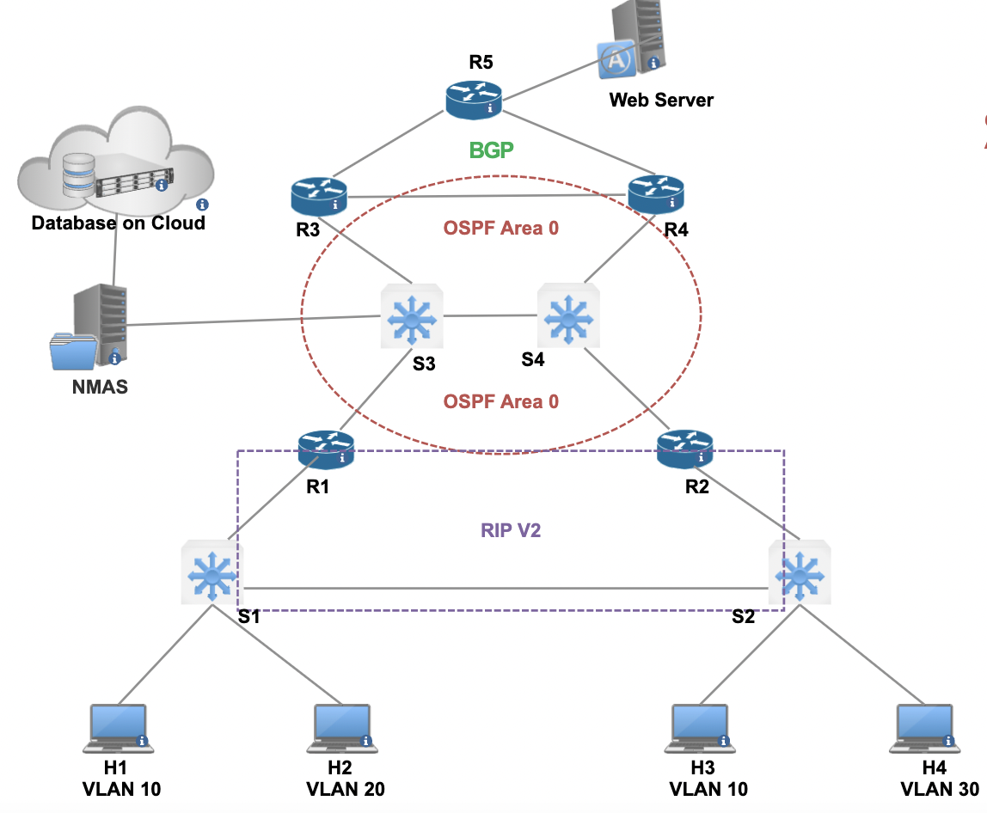

Objective 1: Building the Network Source of Truth

1. Version Control and Change Management
   1. Create a version control system and repo for all of the existing configurations/files and future programming modules
2. Visualization and Ease of Use
   1. Build a Web interface (GUI)
      1. This should incorporate the monitoring and visualization from previous labs
      2. The GUI should allow easy input for adding new devices (or new sites) to the network and changes to the network
         1. I.E. New Device; vendor; WAN IP; Routing Protocol; Which J2 template
3. Templatize the Existing Configuration
   1. I.E. Use a library similar to Netcopa (take existing config > convert to YAML > J2)
4. Golden Configs
   1. Save config (Golden) with timestamp
   2. Extra credit: Add templates for different vendors

Deliverables:

1. A write-up summary of how the NSOT was built
2. Submit a Video explaining and demonstrating functionality of the NSOT (From Objective 1: 1-4)

Part 2 - Infrastructure as Code |Summary:

Infrastructure as Code (IaC) is a paradigm that treats network infrastructure as programmable code, allowing for the management and provisioning of infrastructure through machine-readable configuration files. By adopting IaC, organizations like RoboControl Networks can achieve consistent and reproducible network configurations, automated deployment processes, version control, and increased agility. This approach enables efficient infrastructure management, reduces human errors, and facilitates rapid scaling and provisioning of network resources. With IaC, RoboControl Networks can efficiently manage and evolve their network infrastructure, ensuring it remains adaptable, scalable, and aligned with the organization's changing needs.

# Topololgy:



Objective 1: Building the Automation Framework for IaC

1. IP Address Management (IPAM)
   1. Store all network IPs (method of choice (database or CSV))
2. Permissions
   1. Store Device Management Information (UN/PW)
   2. The passwords should be changed on a regular basis (automatically)
   3. Extra Credit: Use 2FA for device login

Objective 2: Building the DevOps Pipeline

1. Create the DevOps Pipeline (I.E. Jenkins)
   1. Code and configuration changes should automatically trigger a test

Objective 3: Network Automation

1. Develop the necessary Network Automation Applications (Examples below):
   1. Health check information:
      1. Neighborships
      2. Route Table
      3. CPU
      4. IP Connectivity
   2. Configuration Changes
   3. Troubleshooting (To Be Added in future lab)

Deliverables:

1. A write-up summary of how the IaC framework was built
2. Submit a Video explaining and demonstrating functionality of the NSOT and IaC (From all Objectives)